From: https://www.zerohedge.com/markets/deep-ship-deep-dive-supply-chain-crisis

Wait and See (Container 6 of 6)
We summarize what we have shown in the key points below:
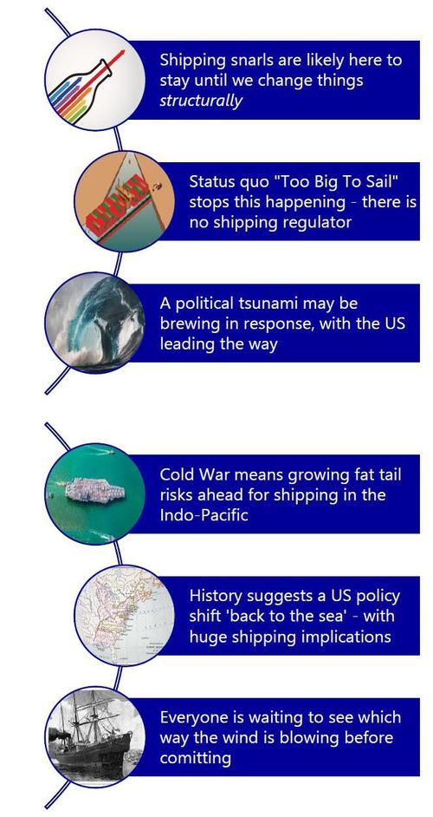

Markets
For markets, there are obvious implications for inflation. How can it stay low if imported prices stay high? How will central banks respond? Rate hikes won’t help. Neither will loose monetary policy – and less it is directed to a directly-related government response on supply chains and logistics.
This suggests greater impetus for a shift to more localised production on cost grounds, at least at the lower end of the value chain, if not the more-desirable higher end. Yet once this wave starts to build, it may be hard to stop. Look at EU plans for strategic autonomy in semiconductors, for example, which are echoed in the US, China, and Japan.
For FX [Foreign Exchange(?)], the countries that ride that wave best will float; the ones that don’t will sink.

Helicopter view of ships
Clearly, shipping will continue to boom. There are huge opportunities in capex [Capital Expense(?)] on ships, ports, logistics, and infrastructure ahead – as well as in new production and supply chains. Yet one first needs to be sure what, or whose, map of production will be used for them!
As the industry sits and waits for the wind and tide to change, logically one wants to position oneself best for what may be coming next. That implies global consolidation and/or vertical integration:
- Large shippers looking at smaller shippers to snuff [sniff] out alternative routes and capacity;
- shippers looking at ports;
- ports looking at shippers;
- giant retailers/producers looking at shippers;
- importers banding together for negotiating power in ultra-tight markets.
Of course, nationally, governments are looking at shippers, or at starting new carriers.
If this is to be a realpolitik power struggle for who rules the waves --“Too Big to Sail”, or a new more national/resilient map of production-- then having greater scale now increases your fire-power. Of course, it also makes you a larger target for others.
Let’s presume current trends continue. Could we even end up with a return to older patterns of production, e.g., where oil used to be produced by company X, refined in its facilities, shipped on its vessels, to its de facto ports, and on to its retail distribution network. Might we even see the same for consumer goods? That is the logic of globalisation and geopolitics, as well as the accumulation of capital.
However, if history is a guide, and (geo)politics is a tsunami, things will look very different on both the surface and at the deepest depths of the shipping industry and the global economy. Much we take as normal today could become flotsam and jetsam.
To conclude, who benefits from the huge profits of the current shipping snarl, and who will pay the costs, is ultimately a (geo)political issue, not a market one.
Many ports are likely going to be caught up in that [tsunami] storm.


